**TUTOR MODULE WIREFRAMES**

1. **Tutor Registration Screen:**

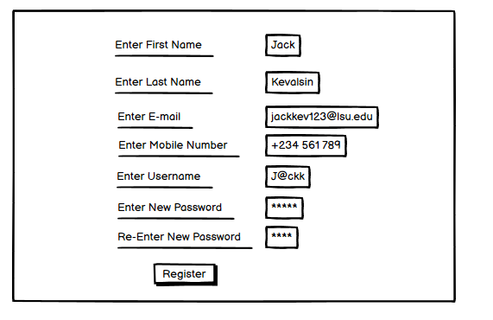

1. **Tutor login screen:**

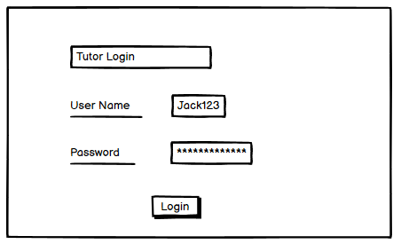

1. **Home page:**

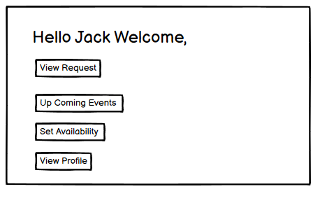

1. **View Requests from Students:**

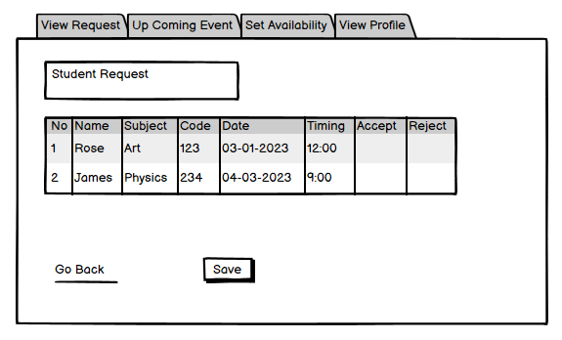

1. **Check Up Coming Appointments:**

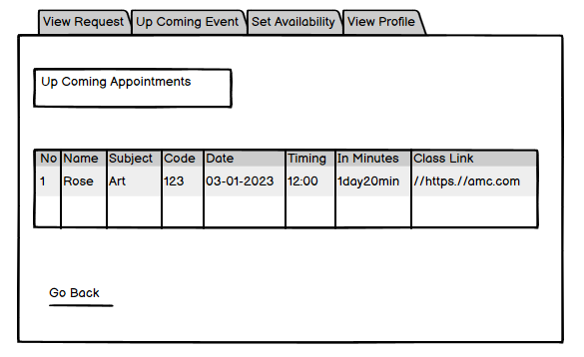

1. **Set Availability Timings:**

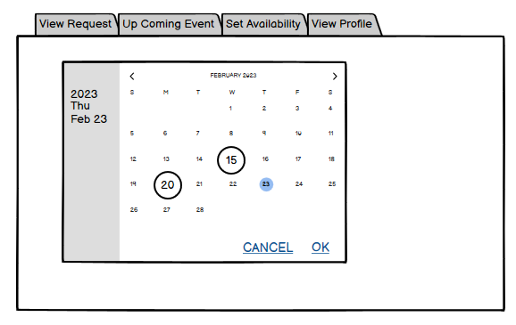

1. **View Profile**

